**Self-Driving and Path Following Car**

Abdelrahman Shrief, Sondos Reda, Asmaa Mohamed, Mohamed Alaa, Mohamed Hossam, Mohamed Nageh, Mahmoud Gaballah and Moamen Mohamed.

Electronics and Communication Department, Pyramids Higher Institute.

**Abstract**

The automotive industry is transforming as vehicles integrate advanced digital technologies, enhancing usability and real-time data access. Among these advancements, self-driving vehicles have emerged as a key focus. Defined by the NHTSA as vehicles capable of operating without human intervention, autonomous cars are set to reshape transportation. This paper reviews the evolution of self-driving technology, from early assistance systems to advanced autonomy levels defined by the SAE, ranging from Level 0 (no automation) to Level 5 (full automation). It also addresses the challenges in achieving full autonomy. Our project contributes by developing basic autonomous functions, such as driving in straight lines and following geometric patterns.

**Introduction**

Nowadays, the majority of vehicles have been converted to digital form. Offer the driver improved ease of use and enhanced data, including up-to-the-minute traffic updates, performance stats evaluation of information similar to velocity, and playing audio online. Cloud computing, among other advancements, has made cars today highly technologically advanced, and there is a lot more yet to happen. Tomorrow's car will transform the automotive industry. Be a significant improvement from what is currently available. Self-driving or autonomous vehicles have become prevalent. a long-cherished aspiration a dream that has consistently been unsuccessful—come into existence. Self-driving vehicles are now a reality. A piece of fiction within the science genre. A highly specific and specialized In the market, the autonomous car sector is progressing quickly. Progress in incorporating numerous technologies from various sources Developing a self-driving car requires a complex ecosystem. To begin with, what exactly are autonomous vehicles? Per the information provided According to the National Highway Safety Administration (NHTSA), self-driving vehicles are cars capable of driving on their own without human assistance. No human intervention is necessary to steer. Increasing speed and reducing speed. The definition above suggests self-driving vehicles equipped with autonomous technologies. Allow the vehicle to travel from Point A to Point B by executing all necessary features needed for a vehicle to operate safely without any passengers inside. Despite the prevailing notion, driverless vehicles are considered a futuristic idea. Competition has commenced to introduce these vehicles onto our streets. These vehicles are causing a disturbance of unprecedented scale and reach.

**Evolution of Self-Driving Technology**

The journey toward autonomous vehicles began decades ago, with early research and development efforts focused on creating automated driving systems. Significant milestones include the development of the first driver assistance systems in the 1980s, the DARPA Grand Challenges in the early 2000s, and the introduction of commercial advanced driver-assistance systems (ADAS) in recent years. This section traces the evolution of self-driving technology.

**Levels of Autonomy**

The levels of autonomy in self-driving vehicles are standardized by the Society of Automotive Engineers (SAE) and range from Level 0 (no automation) to Level 5 (full automation). These levels categorize the extent to which a vehicle can perform driving tasks independently of human intervention, show in figure1.

Level 0: No-Automation

At Level 0, the human driver is responsible for all aspects of driving, including steering, braking, accelerating, and monitoring the environment. The vehicle may have features that provide warnings or momentary assistance, such as automatic emergency braking (AEB) or lane departure warnings, but these do not replace human control. The driver must always be fully engaged. Level1: Function Specific Automation

Level 1: Driver Assistance

Level 1 automation introduces basic driver assistance systems that can take control of either steering or acceleration/deceleration, but not both simultaneously. An example is adaptive cruise control, where the vehicle maintains a set speed and distance from the car in front. The human driver remains responsible for all other aspects of driving and must be ready to take over at any time.

Level 2: Partial Automation

In Level 2, the vehicle can control both steering and acceleration/deceleration simultaneously under certain conditions. Systems like Tesla's Autopilot and GM's Super Cruise fall into this category. While the vehicle can manage some driving tasks, the driver must continuously monitor the environment and be prepared to intervene immediately. Level 2 systems are typically limited to specific scenarios, such as highway driving.

Level 3: Conditional Automation

Level 3 automation, also known as conditional automation, allows the vehicle to handle most driving tasks, including monitoring the environment, but only under certain conditions and with the expectation that the driver will intervene when required. The driver can temporarily disengage from driving tasks, such as in traffic jams, but must be ready to take control when the system requests it. Audi's Traffic Jam Pilot is an example of a Level 3 system, though such systems are not yet widely available due to regulatory and safety concerns.

Level 4: High Automation

The vehicle is capable of performing all driving tasks without human intervention within specific operational domains, such as urban environments or highways during certain weather conditions. A human driver is not needed during these operations, but the system may request that a driver take over in complex or unexpected situations outside its defined domain. Level 4 vehicles can operate autonomously in geofenced areas or under defined conditions but may require human control in other scenarios.

Level 5: Full Automation

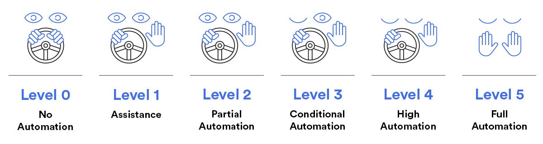Level 5 represents full automation, where the vehicle is capable of performing all driving tasks under all conditions, just as a human driver would. There is no need for a steering wheel, pedals, or any other driver controls because the vehicle can handle every aspect of driving without any human input. These vehicles are envisioned to operate in all environments, including urban areas, highways, and rural roads, regardless of weather conditions or other external factors. Level 5 vehicles are the ultimate goal of autonomous driving technology, but they remain in the conceptual or early testing stages.

figure1. Levels of Autonomy

**Challenges in Achieving Full Autonomy**

Environmental Perception and Understanding

Accurately detecting and interpreting diverse road conditions, obstacles, and other vehicles is a major technical challenge.

Decision-Making in Complex Scenarios

Autonomous systems must be capable of making safe and ethical decisions in unpredictable or rare situations, such as accidents or system failures.

Safety, Reliability, and Redundancy

Ensuring the safety and reliability of AVs, especially in extreme weather conditions or complex environments, is critical for public trust and widespread adoption.

After understanding the stages of self-driving and the challenges we face in achieving it in our project, we are working towards reaching a certain level of autonomous driving by implementing specific commands that the vehicle performs. We started by programming the vehicle to drive in straight lines, followed by regular geometric shapes such as squares, triangles, and rectangles.

This is achieved through code that directs the vehicle to drive a certain distance and then turn at a specified angle, allowing it to trace the desired shape and return to the starting point. We are still working on developing the stage we have reached until we get advanced results from self-driving.

**Conclusion**

The transition to autonomous systems marks a pivotal moment in automotive history, propelled by advances in digital and cloud computing. Once a science fiction concept, self-driving vehicles are now becoming a reality, with various autonomy levels being refined. Achieving full autonomy presents technical and ethical challenges, especially in ensuring safety and reliability. Our project contributes by developing basic autonomous functions like driving in straight lines and geometric patterns, laying the foundation for more advanced capabilities. Ongoing research is essential to fully realize the transformative potential of self-driving technology.